1. Retrieve Students with Their Total Credits Earned

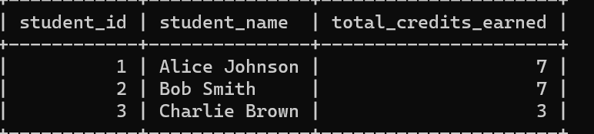

Your query:

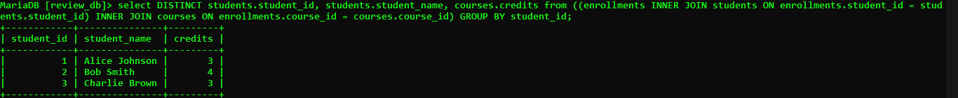

**select DISTINCT students.student_id, students.student_name, courses.credits from ((enrollments INNER JOIN students ON enrollments.student_id = students.student_id) INNER JOIN courses ON enrollments.course_id = courses.course_id) GROUP BY student_id;**

1. Retrieve a List of Courses with the Average Grade

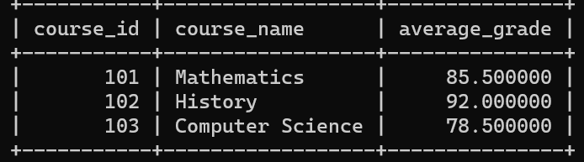

Your query:

select courses.course_id, courses.course_name,avg(grade) as "average_grade" from grades INNER JOIN courses ON grades.course_id=courses.course_id order by course_id asc;

1. Retrieve a list of students along with the courses they are enrolled in, their enrollment dates, and their grades

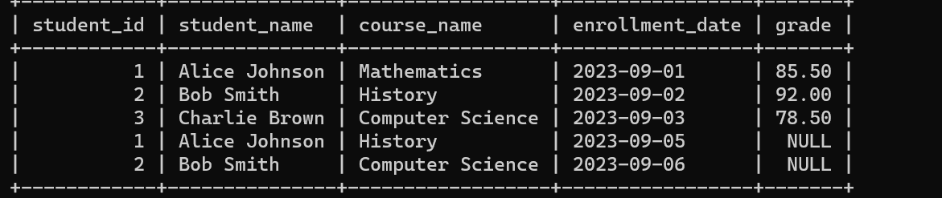



select students.student_id, students.student_name, courses.course_name, enrollments.enrollment_date

-> from ((enrollments

-> inner join students on enrollments.student_id=students.student_id)

-> inner join courses on enrollments.course_id=courses.course_id);

1. Retrieve Courses with the Number of Students Enrolled and Average Grade  
   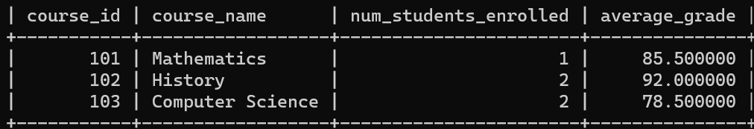

Your query:

1. Retrieve Students with Their Total Credits Earned and Average Grade  
   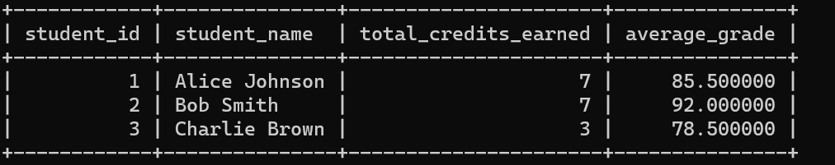

Your query:

1. Retrieve Courses with Their Students and Maximum Grade

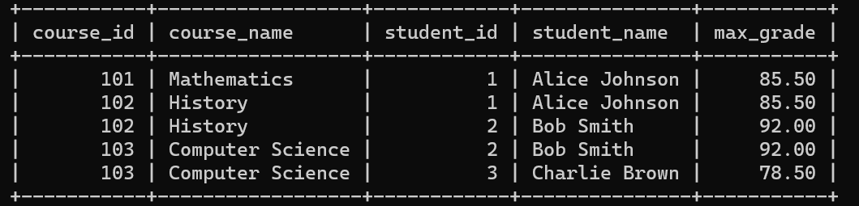

Your query:

1. Retrieve Courses with the Number of Students Enrolled and Their Average Grade

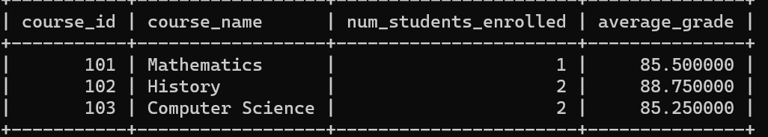

Your query:

1. Write a SQL statement to create a VIEW named “StudentInfo” to show all the students

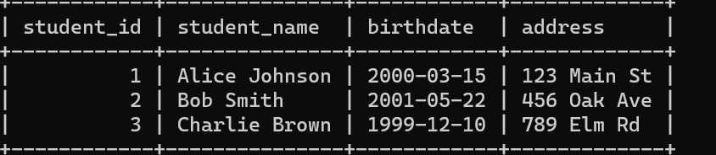

You query:

1. Write a SQL statement to create a VIEW named “StudentEnrollmentDetails” to show all detail of enroll.

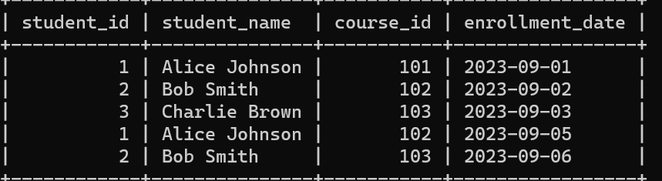

Your query:

1. Write a SQL statement to create a VIEW named “CourseEnrollmentStats” to show about courses, including the course name, the number of students enrolled, and the average grade for each course.

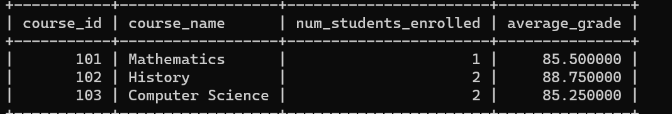

Your query:

1. Create a view to retrieve student information with enrollment statistics and average credits greater than 3(name: **StudentEnrollmentStats**)

